|  |  |  |
| --- | --- | --- |
| **LAB 321Assignment** | **Type:** | **LongAssignment** |
| **Code:** | **J3.L.P0016** |
| **LOC:** | **500** |
| **Slot(s):** | **12** |

**Title:** Grey Consulting Group

**Background**

### You want to be a famous supplier of IT consultant?

Complete this assignment to start your business now☺

Reference site:<http://us-123office.simplesite.com/>

**Program Specifications**

Program a web site tointroduce your IT consultant services, detail functions of this website is described below

**Features:**

This website contains 3 main functions

* Function 1 : Home page : ( see PIC 01)
  + Display introduction entry and short description about : services and contact
  + Each productcontains
    - Entry name
    - Description picture
    - Entry description
* Function 2 : Services ( PIC 02)
  + Print out detail services
* Function 3 : Contact ( PIC 03)
  + Help user to submit her requests

You do not need to write interface for admin control panel, you can add data manually (use SQL SERVER Management studio).

Note: All data must be load from database, not hard code in page.

***Expectation of User interface:***

Pic 01 : Home Page

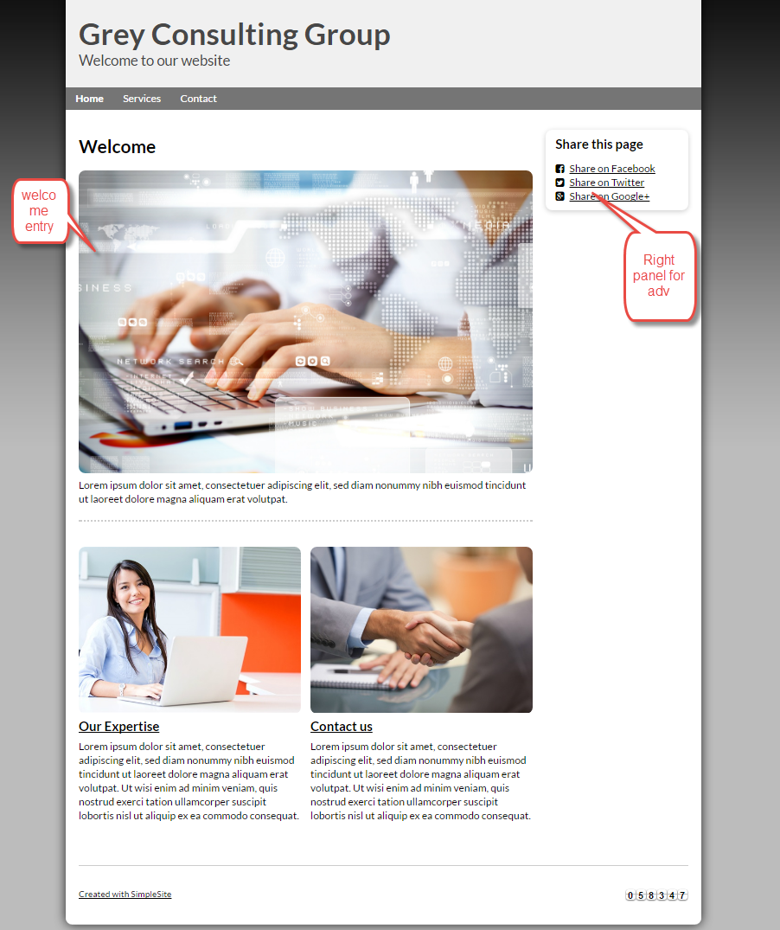

PIC 2 :Services

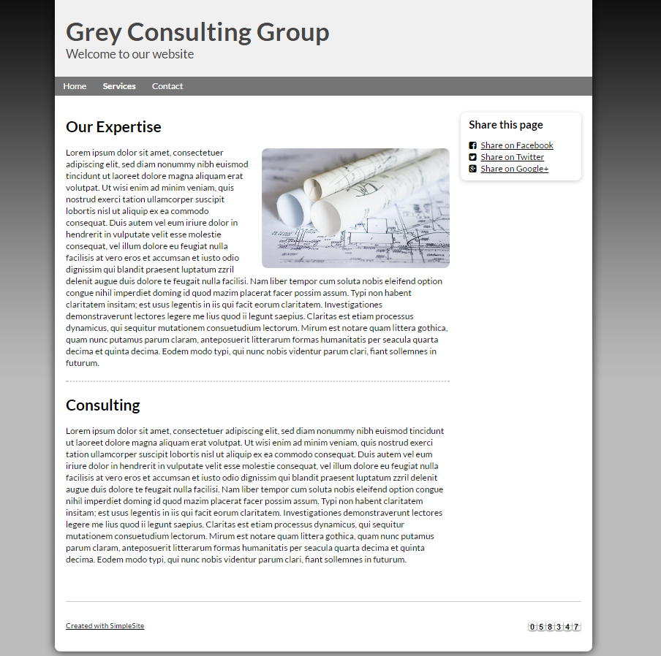

PIC 3 : Contact : allow user to submit message here

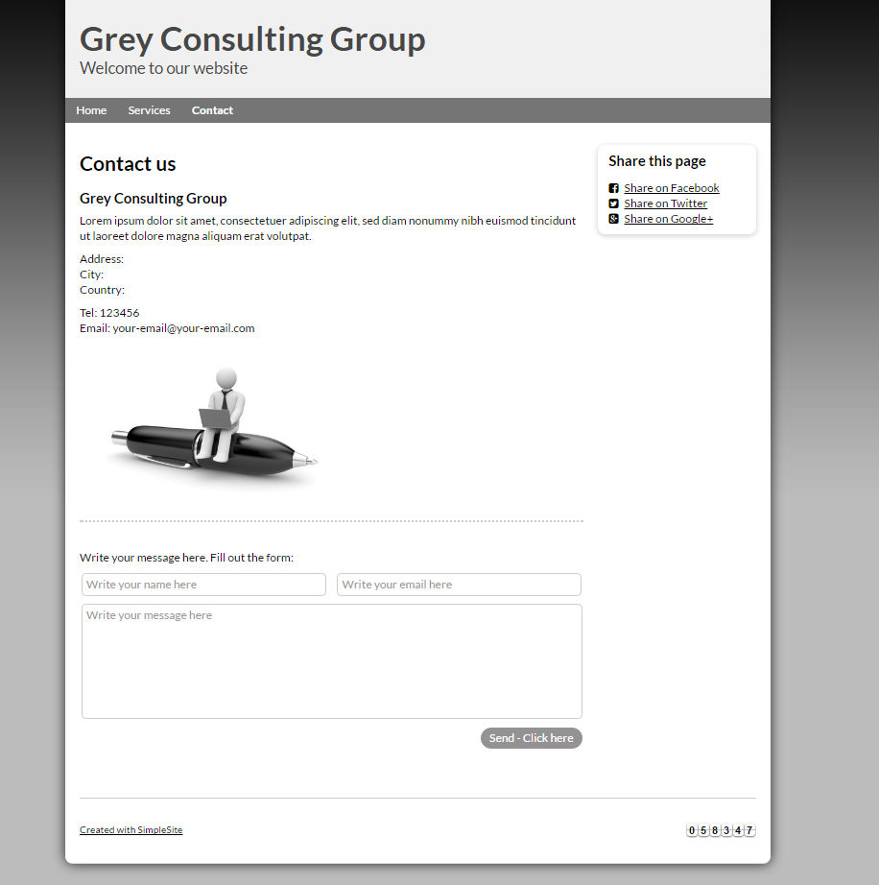

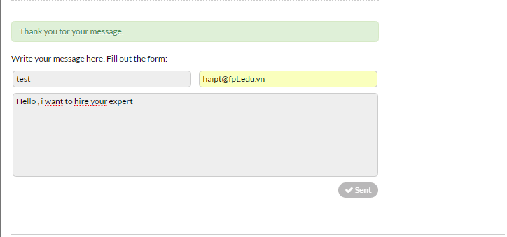

**Guidelines**

* Step 1 : Create web layout
* Step 2 : Create prototype
* Step 3 : Design database base on created prototype
* Step 4 : Code & Test